**ADDRESSED TO: DR. MICHEL WHITTENBERG, THE VICE PRESIDENT**

**OF OPERATIONS**

**SUBMITTED BY** **GROUP 33**

AJAY SINGH RATHORE

ANURAG PATIL

MANISHA VERMA

RAISA CALLISTUS

**THE COMPUTER CONTROLLED CONVEYOR BELT PROJECT**

**CONTENTS:**

# Project Life Cycle 4

## Defining Phase 4

### Goals 4

### Specifications 4

### Work Breakdown Structure 5

### Responsibilities 5

## Planning Phase 6

### Schedule 6

### Critical Path 6

### Resources 7

### Budget 7

### Risk Management 8

## Executing Phase 9

### The First Quarter 10

### The Second Quarter 11

### The Third Quarter 12

### The Fourth Quarter 13

### Revised Fourth Quarter 14

### Management issues 14

### Keys to Success 14

## Closure Plan 15

### Delivery Acceptance 15

* + 1. Conclusion 15

1. **References 16**

# Appendices 17

**List of figures:**

|  |  |  |
| --- | --- | --- |
| **S.no** | **Title** | **Page number** |
| 1 | Project Priority Matrix | 1 |
| 2 | Initial Work Breakdown structure | 2 |
| 3 | Organizational Resources | 4 |

**List of tables:**

|  |  |  |
| --- | --- | --- |
| **S.no** | **Title** | **Page number** |
| 1 | Risk Assessment Form | 5 |
| 2 | Risk Response Matrix | 6 |
| 3 | Status Report First Quarter | 7 |
| 4 | Status Report Second Quarter | 7 |
| 5 | Status Report Third Quarter | 8 |
| 6 | Status Report Fourth Quarter | 9 |
| 7 | Revised status Report for Fourth Quarter | 10 |

**1. Project Life Cycle**

**1.1 Defining Phase**

**1.1.1 Goals**

To build a new computer-controlled conveyor belt system in a span of 2 years with the budget not exceeding $1.6 million.

**1.1.2 Specifications**

After communicating with the project sponsors, stakeholders and executive management, the team was able to gather specific requirements for the project**.** Firstly, the new computer-controlled conveyor belt must be able to move and position items on the conveyor belt with less than 1 millimeter. The project should create a new system that will replace the old system at a low cost. The conveyor belt should have a potential critical unit of 30% of the systems installed in the factories. It should be easier to update with future technologies as and when required. The technical requirements of the project must meet a specific standard that must be maintained throughout the life of the project.

It was also established that the project would be time constrained. Apart from this the project would enhance scope and accept cost as shown in the Project Priority Matrix below (figure 1).

|  |  |  |  |
| --- | --- | --- | --- |
|  | **Time** | **Scope** | **Cost** |
| **Constrain** | X |  |  |
| **Enhance** |  | X |  |
| **Accept** |  |  | X |

***Figure 1: Project Priority Matrix***

In addition to the goals, project deliverables were identified, milestones were set, and technical requirements were established. After more information was gathered, certain limits and exclusions were identified. It was found that the project team cannot work more than 40 hours a week without taking permission from the Vice President. The team would work from Monday through Friday and would comply with U.S government holidays. *Refer to Appendix 1.1 for the Project Scope Statement.*

**1.1.3 Work Breakdown Structure**

After finalization of the system specifications, the team then set few milestones for the project, namely:

1. Start hardware development.
2. Complete setting up operating system.
3. Complete utilities.
4. Complete system integration.

The team then constructed a Work Breakdown Structure(WBS) that outlines the tasks which needs to be completed. Figure 2 below shows the Work Breakdown Structure which was approved by the VP of operations.

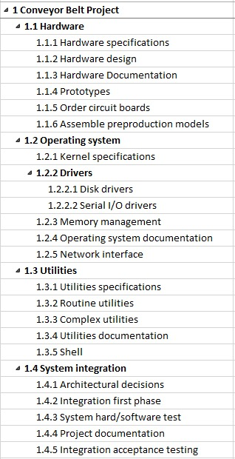

***Figure 2: Initial Work Breakdown Structure***

**1.1.4 Responsibilities**

In this project, we as a team decided that the work should be divided equally among the team members. This was done to provide each member with equal learning opportunity. The project had five different deliverables which had to be presented to our VP. Each task was performed as a group for each of the interim delivery. We maintained proper communication between the members of the group as the project was being implemented.

**1.2 Planning Phase**

After completing the defining phase, we move to the planning phase of the project where we have an approved set of goals, priorities and work breakdown structure. This is a very important phase for the project, as in this phase we create an accurate plan for the project, allocate resources to the activities and assess the risks. The success of this phase defines the future of the project. We set the objectives and paths to complete the project.

**1.2.1 Schedule**

In this phase, we find the time taken by each activity to complete. A network diagram given in the figure in Appendix 2.2 shows the activities that are critical, it also identifies the number of days required by each activity to complete. The estimated completion date for The Conveyor Belt Project is February 1st,2018 and the project will take 530 days to complete. *Please refer to Appendix 2.2 for the network diagram.*

**1.2.2 Critical Path**

Architectural decision (ID:24) 🡪

🡪Hardware Specifications (ID: 3) 🡪

🡪Hardware Design (ID:4) 🡪

🡪Hardware Documentation (ID: 5) 🡪

🡪Integration first phase (ID:25) 🡪

🡪Serial I/O driver (ID: 13) 🡪

🡪System hardware/Software test (ID: 26) 🡪

🡪Network interface (ID: 16) 🡪

🡪Integration acceptance testing (ID: 28)

**1.2.3 Resources**

Once the schedule is in place, we then assign the resources. Figure 3 shows us the cost involved and the resources allocated.

|  |  |  |
| --- | --- | --- |
| **Name** | **Group** | **Cost $/hr.** |
| **Design** | R&D (2 Teams) | $100 |
| **Development** | R& D (2 Teams) | $70 |
| **Documentation** | R&D (1 Team) | $60 |
| **Assembly/Test** | R&D (1 Team) | $70 |
| **Purchasing** | Procurement (1 Team) | $40 |

***Figure 3: Organizational Resources***

During the resource allocation, three resources were over allocated- **design, development and documentation.** We used levelling within slack to resolve this issue. Appendix 2.3 shows us how the project looks after levelling within slack. One resource is still overallocated – **development.** The duration of the project is still 530 days as we levelled within slack.

To fix the overallocation we use levelling outside slack (refer Appendix 2.4). Overallocation has been resolved but the project duration has increased from 530 days to 725 days. This was reported to the senior management and the solution to this was addition if resources to maintain the timelines of the project.

Therefore, 2 development teams and 1 external team was added. (refer Appendix 2.5) The duration for the project remains 530 days after adding resources and the overallocation problem is also resolved. The critical path has changed after adding resources. The overall sensitivity of the network is higher now, as the slack of certain activities have reduced.

**1.2.4 Budget**

**Budget Reserve** is for identified risks that influences baseline costs. The total budget reserve for the project was determined as $44,540 using the quantitative method of assessing each identified risk and its probability.

|  |
| --- |
| Budget Reserves = Probability of the risk * Cost Impact if occurred |

**Management Reserve** is the percent of the total project budget reserved for contingency that covers unforeseen risks. In our case, we assumed our budget reserve to be three times of Budget Reserve which is $133,620.

**1.2.5 Risk Management**

After solving the resource overallocation and assigning costs, a detailed risk assessment was performed. Risk Assessment Form (table 1) tells us about the different risks and their impacts and likelihood.

|  |  |  |  |  |
| --- | --- | --- | --- | --- |
| **Risk Event** | **Likelihood** | **Impact** | **Risk Score** | **When** |
| Raw materials cost increase | 2 | 3 | 8 | Purchasing |
| Failure of mechanical components | 2 | 5 | 11 | Testing Phase |
| Network Interface Failure | 3 | 4 | 14 | Integration Acceptance Testing |
| Natural Calamity | 1 | 5 | 5 | At any Phase |
| User inability to operate system | 3 | 4 | 14 | Post Installation |

***Table 1: Risk Assessment Form***

Risk Response Matrix (table 2) the person who is responsible in case the risk event occurs.

|  |  |  |  |  |
| --- | --- | --- | --- | --- |
| **Risk Event** | **Response** | **Contingency Plan** | **Trigger** | **Who Is Responsible** |
| Raw materials cost increase | Transfer | Make contract with supplier | Increase in Market values | Supplier |
| Failure of mechanical components | Mitigate | Buy spare parts during purchasing | Equipment fails | Purchasing team |
| Network Interface Failure | Accept | Identify the reason behind failure and resolve it | Compatibility issue | Assembly/Test |
| Act of god | Transfer | Have insurance to cover the cost | Natural Calamity | Insurance provider |
| Accept | Extend the duration of project |
| User inability to operate system | Avoid | Provide detailed User Guide | User unable to operate the system | Documentation Team |

***Table 2: Risk Response Matrix***

**1.3 Executing Phase**

The last step in the planning phase is to finalize the budget. This phase deals with the quarterly status reports and changes made in the quality. The reports below show the status reports for the four quarters:

1. First quarter report- April 1st, 2016.
2. Second quarter report- July 1st, 2016.
3. Third quarter report- October 1st, 2016.
4. Fourth quarter report- January 1st, 2017.

**1.3.1 The First Quarter (April 1st, 2010)**

|  |  |  |  |  |  |
| --- | --- | --- | --- | --- | --- |
| **PV** | **EV** | **AC** | **SV** | **CV** | **BAC** |
| $126,800.00 | $155,980.83 | $151,680.00 | $29,180.83 | $4,300.83 | $1,229,360.00 |
| **MRI** | **VAC** | **EACf** | **CPI** | **PCIB** | **PCIC** |
| 0.032 | $33,892.22 | $1,195,823.16 | 1.028 | 0.127 | 0.127 |

***Table 3: Status Report for First Quarter***

The planned value (PV) of the time phased baseline is $126,800.00. The earned value (EV) for the task is $155,980.83 whereas, the actual cost (AC) of the work completed is $151,680, so, the cost variance is $4,300.84. Since, the cost variance (CV) is positive based on what work has been completed to date we are over budget. The estimated cost at completion (EAC) is $1,195,467.78. A CPI of 1.028 indicates that we are earning $1.03 for every dollar we are spending. An SPI of 1.23 indicates that $1.23 worth of work has been accomplished for every dollar worth of scheduled work, we are ahead of schedule. The TCPI is 1 meaning that we are earning $1 for every dollar we spend.

Assuming the CPI remains constant throughout the project, the cost of completion will be around $1,195,823.16 (). The planned cost of completion (BAC) is $1,229,360.00. The difference between the two given by the VAC is positive $33,892.22 meaning under budget. Finally, the scheduled variance (SV) is $29,180.83 which is the work that has been completed ahead of schedule without being planned.

Below is a cash flowchart for Q1

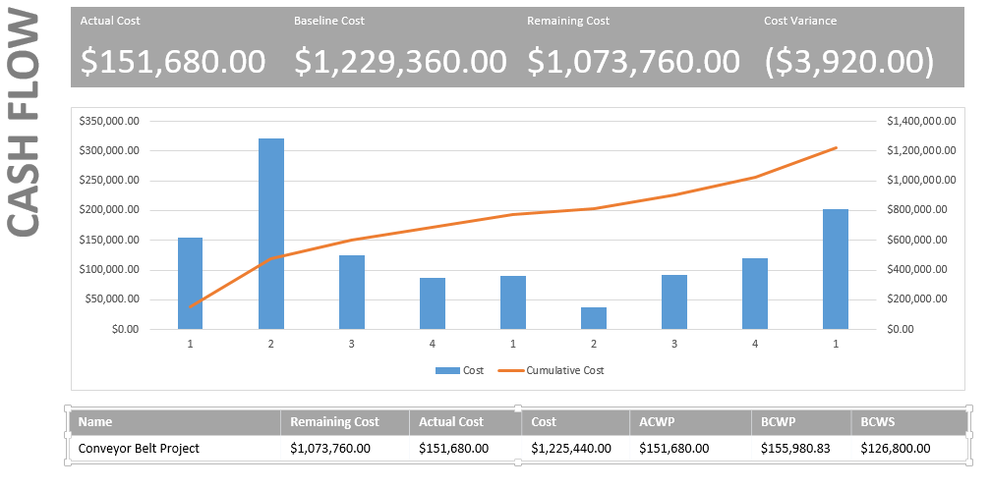

**1.3.2 The Second Quarter (July 1st, 2010)**

|  |  |  |  |  |  |
| --- | --- | --- | --- | --- | --- |
| **PV** | **EV** | **AC** | **SV** | **CV** | **BAC** |
| $422,800.00 | $454,535.90 | $470,720.00 | $31,735.90 | ($16,184.10) | $1,229,360.00 |
| **MRI** | **VAC** | **EACf** | **CPI** | **PCIB** | **PCIC** |
| -0.1211 | ($43,779.30) | $1,269,507.73 | 0.97 | 0.37 | 0.37 |

***Table 4: Status Report for Second Quarter***

The planned value (PV) of the time phased baseline is $422,800. The earned value for the task is $454,535.90 whereas, the actual cost of the work completed is $470,720.00 so, the cost variance is negative $16,184.10. Since, the cost variance (CV) is negative, we are under budget. The estimated cost at completion (EAC) is $1,273,139.30. A CPI of 0.97 indicates that we are earning 97 cents for every dollar we are spending. An SPI of 1.08 indicates that $1.08 worth of work has been accomplished for every dollar worth of scheduled work, we are behind schedule. The TCPI is 1.02.

Assuming the CPI remains constant throughout the project, the cost of completion will be around $1,269,507.73 (). The planned cost of completion (BAC) is $1,229,360.00. The difference between the two given by the VAC is negative $43,779.30 meaning we are over budget. Finally, the scheduled variance (SV) is negative $31,735.90

Below is a cash flowchart for Q2

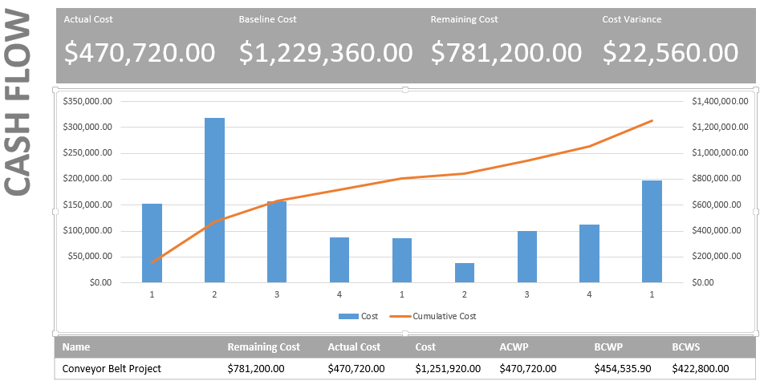

**1.3.3 The Third Quarter (October 1st, 2010)**

|  |  |  |  |  |  |
| --- | --- | --- | --- | --- | --- |
| **PV** | **EV** | **AC** | **SV** | **CV** | **BAC** |
| $599,440.00 | $609,520.00 | $631,600.00 | $10,080.00 | ($22,080.00) | $1,229,360.00 |
| **MRI** | **VAC** | **EACf** | **CPI** | **PCIB** | **PCIC** |
| -0.1652 | ($44,534.62) | $1,270,610.30 | 0.97 | 0.495 | 0.495 |

***Table 5: Status Report for Third Quarter***

The planned value (PV) of the time phased baseline is $599,440. The earned value for the task is $609,520 whereas, the actual cost of the work completed is $631,600 so, the cost variance is negative $22,080. Since, the cost variance (CV) is negative based on what work has been completed to date we are under budget. The estimated cost at completion (EAC) is $1,273,894.62. A CPI of 0.97 indicates that we are earning 97 cents for every dollar we are spending. An SPI of 1.02 indicates that $1.02 worth of work has been accomplished for every dollar worth of scheduled work, we are ahead of schedule. The TCPI is 1.04.

Assuming the CPI remains constant throughout the project, the cost of completion will be around $1,270,610.30 (). The planned cost of completion (BAC) is $1,229,360. The difference between the two given by the VAC is negative $44,534.62 meaning we are over budget. Finally, the scheduled variance (SV) is positive $10,080.

Below is a cash flowchart for Q3

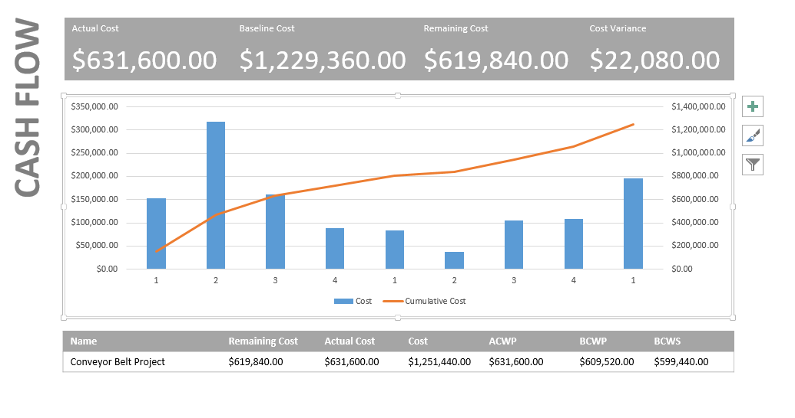

**1.3.4 The Fourth Quarter (January 1st, 2011)**

|  |  |  |  |  |  |
| --- | --- | --- | --- | --- | --- |
| **PV** | **EV** | **AC** | **SV** | **CV** | **BAC** |
| $683,440.00 | $688,384.92 | $717,840.00 | $4,944.92 | ($29,455.08) | $1,229,360.00 |
| **MRI** | **VAC** | **EACf** | **CPI** | **PCIB** | **PCIC** |
| -0.22 | ($52,606.85) | $1,281,355.70 | 0.96 | 0.56 | 0.56 |

***Table 6: Status Report for Fourth Quarter***

The planned value (PV) of the time phased baseline is $683,440. The earned value for the task is $688,384.92 whereas, the actual cost of the work completed is $717,840 so, the cost variance is negative $29,455.08. Since, the cost variance (CV) is negative based on what work has been completed to date we are under budget by $29,455.08. The estimated cost at completion (EAC) is $1,281,966.85. A CPI of 0.96 indicates that we are earning 96 cents for every dollar we are spending. An SPI of 1.01 indicates that $1.01 worth of work has been accomplished for every dollar worth of scheduled work, we are ahead of schedule. The TCPI is 1.06.

Assuming the CPI remains constant throughout the project, the cost of completion will be around $1,281355.70, (). The planned cost of completion (BAC) is $1,229,360. The difference between the two given by the VAC is negative $52,606.85 meaning we are over the budget. Finally, the scheduled variance (SV) is positive $4944.92. The project is 19 days behind schedule. The Project is estimated to finish on 02/28/2018. The project percent complete in terms of budget (PCIB) is 56% and in terms of cost (PCIC) is 56%.

Below is a cash flowchart for Q4

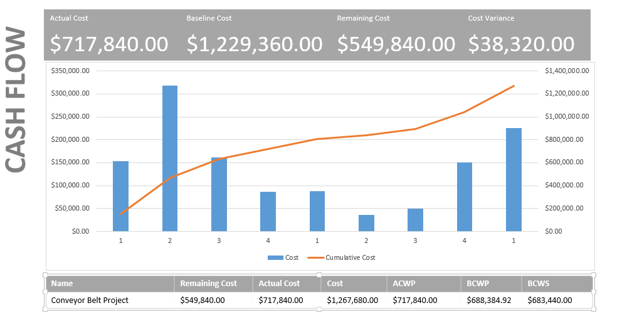

**1.3.5 Revised Fourth Quarter**

|  |  |  |  |  |  |
| --- | --- | --- | --- | --- | --- |
| **PV** | **EV** | **AC** | **SV** | **CV** | **BAC** |
| $683,440.00 | $687,253.60 | $717,840.00 | $3,813.60 | ($30,386.40) | $1,229,360.00 |
| **MRI** | **VAC** | **EACf** | **CPI** | **PCIB** | **PCIC** |
| -0.227 | ($54,713.61) | $1,282,534.16 | 0.96 | 0.56 | 0.56 |

***Table 7: Revised Status Report for Fourth Quarter***

Below is a cash flowchart for Q4 revised

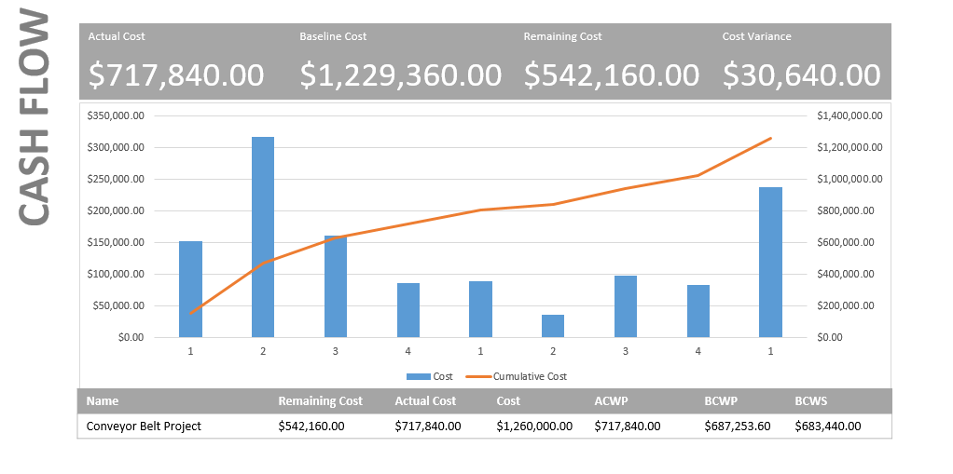

**1.3.6 Management issues**

1. Lack of communication, professional or personal issues or conflicts can affect the project.
2. Due to pressure of completing the project within schedule there are possibilities of committing mistake or over analysis to avoid mistakes.
3. There can be scenarios where the resources won’t be available when needed.

**1.3.7 Keys for Success**

1. Encourage team members and emphasize on team building.
2. Effective and timely communication.
3. Have good vacation and holiday plans for team members.
4. Weekly status meeting and reports.
5. Cross training for all the critical activities

**1.4 Closure Plan**

Project Closure phase involves handing the deliverables, document the lessons learnt and experiences, releasing resources, reassigning project team members and delivering the final product to the customer. This phase will also involve the training of customers.

**1.4.1 Delivery Acceptance**

Delivery acceptance is a crucial part of the closure process. The complexity of the deliverables vary from project to project. We came across multiple deliverables throughout the project life cycle of which few were to be delivered to the customer and few to the VP of Operations. We had constant guidance on the deliverables which made it smooth overall for us to constantly track the performance.

**1.4.4 Conclusion**

**1.4.3.1 Executive Summary**

The status report and the other metrics tell us that the project will be delayed by 30 days but we are still under budget.

We first started with the project scope statement. The milestones were unacceptable from the first deliverable. We corrected the same as per the review comments and delivered it. Then we determined a critical path. A Gantt chart and a schedule table were prepared. Then came the turn to assign resources in which we faced issues of overallocation. We first levelled with slack and then used additional resources so as to overcome the issue. Next, we set the baseline for the project and created a cash flow chart. The final interim dealt with status report and identification of management issues and keys to success.

**1.4.3.2 Lessons Learnt**

1. Strong and effective communication.
2. Effective time management.
3. Understanding the problem
4. Decision making
5. Correct interpretation and execution
6. Ability to take up responsibilities.

**Reference**

Dr. Michel Whittenberg, VP of Operations.

**Project Management, The Managerial Process** book by Erik W. Larson, Clifford F. Grey.

**PMBOK guide** (Project Management Body of Knowledge).

## Appendices

Appendix 1: Project Scope Statement ………………………………………………………….. 18

Appendix 2: Network Diagram ………………………………………………………………….19

Appendix 3: Gantt Chart – Leveling Within Slack ……………………………………………...20

Appendix 4: Gantt Chart – Leveling Outside of Slack ……………………………….………... 21

Appendix 5: Gantt Chart after External Team Addition ……………………………………...... 22

Appendix 6: Quarter 4 Earned Value Report …………………………………………………... 23

Appendix 7: Quarter 4 Gantt Tracking Chart …………………………………...……………... 24

**APPENDIX 1:**

**PROJECT SCOPE STATEMENT**

**PROJECT OBJECTIVES:**

To build a new computer-controlled conveyor belt system in a span of 2 years with the budget not exceeding $1.6 million.

**DELIVERABLES:**

1. Hardware.
2. Operating System.
3. Utilities
4. System Integration.

**MILESTONES:**

1. Start hardware development by TBD.

2. Complete setting up operating system by TBD.

3. Complete utilities by TBD.

4. Complete system integration by TBD.

**TECHNICAL REQUIREMENTS:**

1. Items will be positioned within one millimeter on the conveyor belt.

2. Tensile strength of belt shall not exceed 1000 units.

3. New system will be compatible and open to any changes in the future.

4. Belt shall not exceed 1000 revolutions per minute.

5. Hardware Components should follow CEMA (Conveyor Equipment Manufacturing Association) standards.

6. Belt and drum surface temperature shall not be more than 350°F.

7. Belt shall be used on small diameter pulleys without any lacing.

8. Special features shall be added to avoid accidents.

**LIMITS AND EXCLUSIONS:**

1. Normal working hours for the project team (40 hours a week).

2. Overtime is allowed only on Project Sponsor approval.

3. Project team complies with normal holidays.

4. Cleanliness will be maintained by concerned staff.

5. Project Sponsor approval is required for anything related to budget.

6. Project team is responsible for knowledge transfer and training.

7. End user is responsible for future upgrades.

**CUSTOMER REVIEW:**

Dr. Michel E. Whittenberg, VP Operations

**Appendix 1.2**

**Network Diagram**

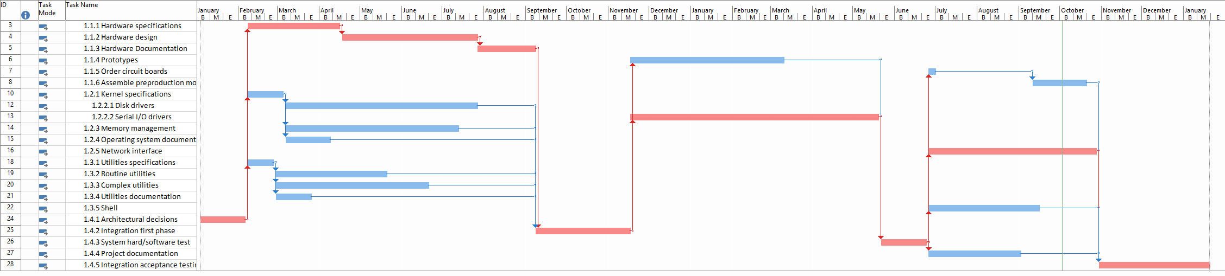

**Appendix 1.3**

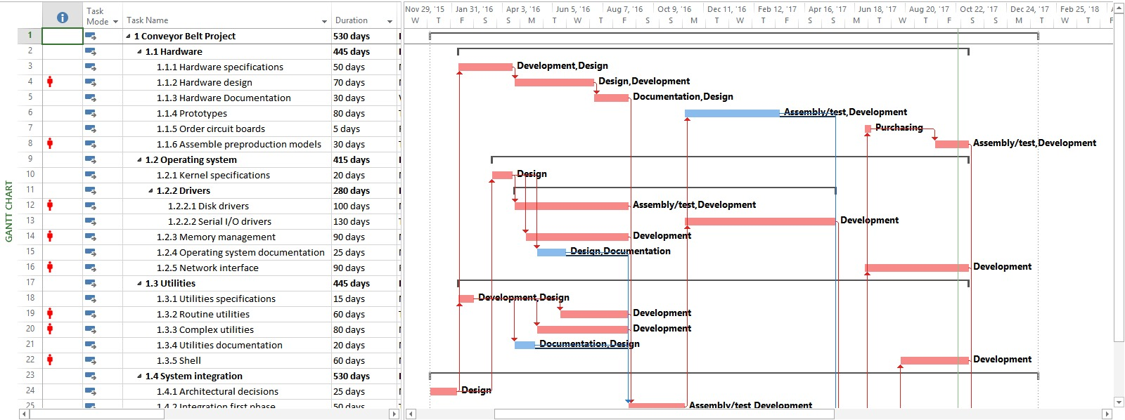

***Resources leveled within slack***

**Appendix 1.4**

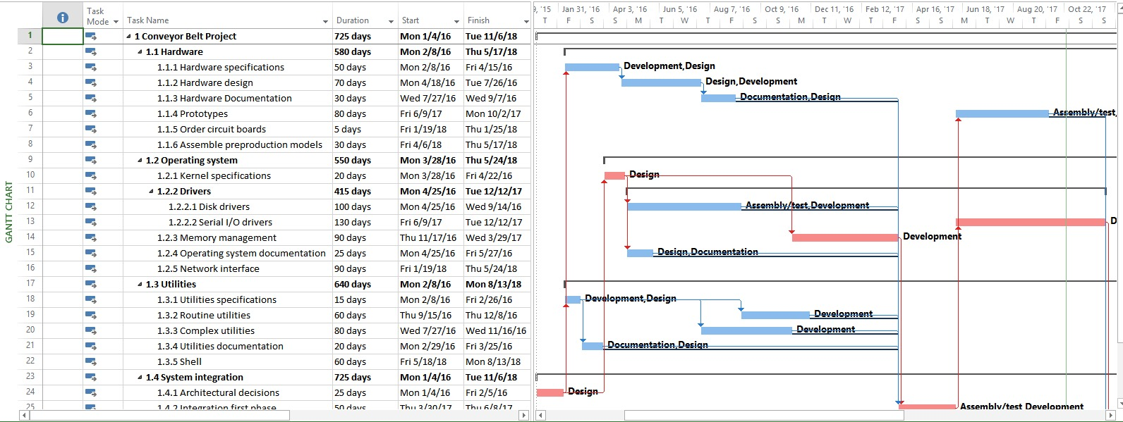

***Resources levelled outside slack***

**Appendix 1.5**

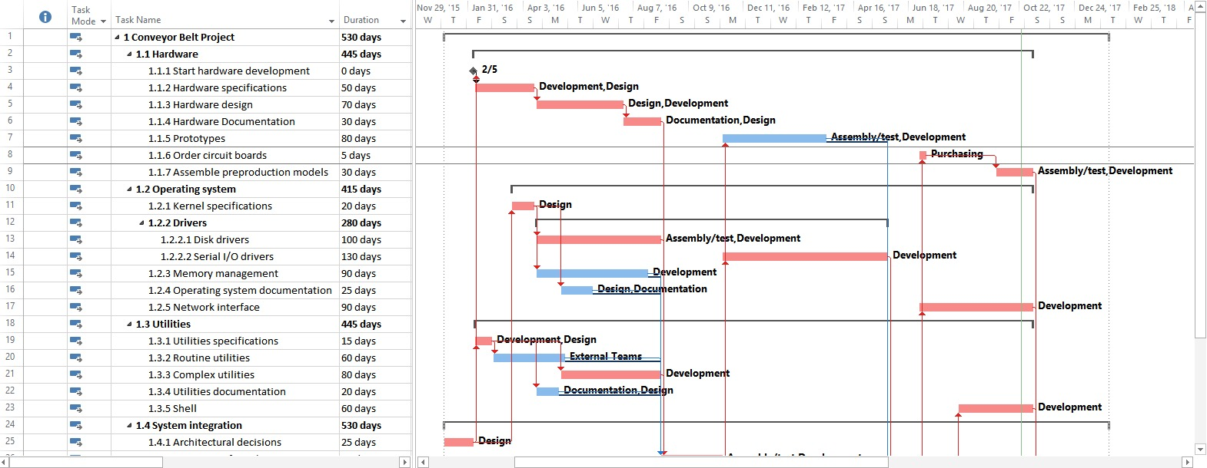

***Levelled with additional resources***

**Appendix 1.6**

**Earned Value Report**

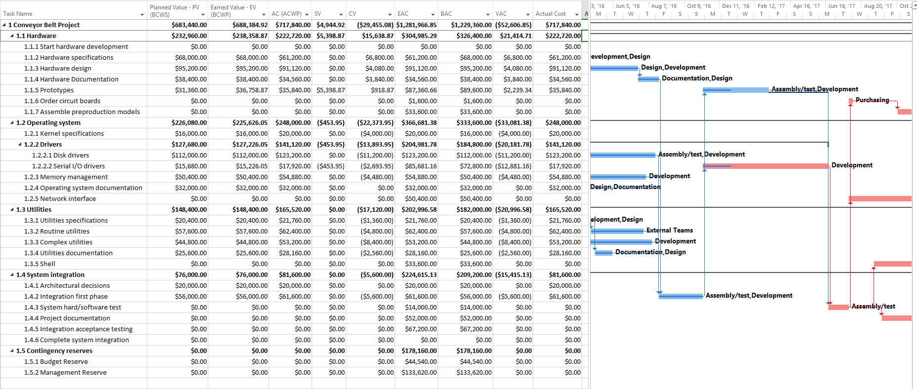

**Appendix 1.7**

**Tracking Gantt chart**

